Lieutenant Colonel Scott Nowlin
United States Air Force Academy
Department of Aeronautics
Colorado Springs, CO 80840-9499

December 7, 2012
Dear Lieutenant Colonel Nowlin,
Thank you for your request of information on the Spruce Goose aircraft built by Howard Hughes. I enjoyed delving into the fascinating history of this aircraft and locating the variety of resources you requested. I believe these resources and others I located will assist you in your display of the original blueprints and other ephemera the USAFA received from your donor.
The resources I was able to locate include the following:
- Articles on the aircraft from the time of its one and only flight on November 2, 1947 as well as articles about its move to its current location
- Newsreels of the construction and flight of this behemoth
- Current location of the aircraft and contact information of the appropriate department in the museum
- Several suggestions of books that the US Air Force Academy may want to include in their collection
- Images of the Spruce Goose from several organizations, including the Betteman archive and the Evergreen Museum (the current owner of the airplane)
As you now, the Spruce Goose was a nickname given the aircraft by the media at the time. It is also known by its government designation NX37602 as well as the Hughes H-4 Hercules, and simply the Hercules. It was built of plywood; primarily birch (ironically) plywood, to be specific (Popular Mechanics, 1948).
In order to best access the resources I located, I have gathered most of them in a Zotero folder, which I will invite you to so you can access the items that are available online. If you prefer to not receive them in this manner, I can make them available to you as a bibliography in a word document; however, much of the functionality within Zotero makes it easier to access the articles, PDFs, websites, images, videos, and books.
I have included in this document an explanation of the resources in hopes of making them easier to understand in the context of this information request. Many of the items will require follow-up contact in order to garner the proper permissions for exhibition and/or to get larger and better quality images. Much may fall under Fair Use guidelines as this is for an educational institution and scholarship and research are paramount in the use of these materials, but your staff will need to follow up on this to insure compliance. The U.S. Copyright’s Office website on Fair Use is: http://www.copyright.gov/fls/fl102.html
Some of the items may require assistance from your library to access. If they have any questions or concerns, please feel free to give them my contact information and I will be happy to work with them directly.
I have some contact information for several organizations that you may want to contact in order to request reproductions and permissions:
The Long Beach Public Library has the archives for the Long Beach newspaper, the Press-Telegram. The newspaper itself only has archives going back to 1990, so the library is a better resource for display-quality images as well as articles from the day of the flight.
Library contact information:
Long Beach Public Library
101 Pacific Avenue
Long Beach, CA 90822
Phone: (562) 570-7500
Fax: (562) 570-7408
Email: LBPL_comments@lbpl.org

As you know, the Spruce Goose is now located in the Evergreen Museum in McMinnville, Oregon. They will be a good resource for images and information.
The Spruce Goose is currently located at the Evergreen Museum in Oregon:
http://www.evergreenmuseum.org/the-museum/aircraft-exhibits/the-spruce-goose/
Address:
500 NE Captain Michael King Smith Way
McMinnville, OR 97128
Phone: 503-434-4185 (general)
Collections/Research
collections@sprucegoose.org

Unfortunately I was unable to locate any information regarding a beaching structure and the Spruce Goose. This may have been something that Mr. Hughes and his team planned on building, but that never came to fruition. A discussion with the staff at the Evergreen Museum might prove fruitful in this area!
The Curator at the Evergreen museum is Stewart Bailey and his phone number is 503-434-4941. You can read a blog post he wrote on May 16, 2011 on the Spruce Goose here: https://loftyambitions.wordpress.com/category/aviation/page/4/

I have gathered together a multitude of information on the Spruce Goose and its history. I have organized it by format:
Articles
- “Drive Began to Save World’s Biggest Plane.” New York Times 23 Mar. 1975: 61.
- “Employees of Hughes View His ‘Spruce Goose’.” New York Times 8 Mar. 1978: A18.
- “The Hercules’: The World’s Largest Plane Is Now Under Construction.” New York Times 17 July 1945.
- “Hughes ‘Spruce Goose’ Safe for Another Year.” New York Times 5 Aug. 1975.
- “Law Signed to Preserve Aircraft.” New York Times 30 Aug. 1980: 22.
- “Navy and NASA Indicate Interest in Reactivating Hughes’s Big Plane.” New York Times 25 Nov. 1976.
- “Order Wooden Plane Resumed.” New York Times 18 Apr. 1944.
- Rymer, Russ. “Oregon: IN McMINNVILLE THE GOOSE HAS LANDED.” New York Times 12 Sept. 2004. Web. 3 Dec. 2012.
- “The Spruce Goose Will Take Off.” New York Times 2 Aug. 1992: XX3.
- “The ‘Spruce Goose,’ Hughes’s Plywood Airplane, to Go to Eight Museums.” New York Times 2 Mar. 1975.
- TIMES, GLADWIN HiLLSpecial to THE NEW YORK. “HUGHES LAUNCHES GIANT FLYING BOAT: Plane Under Senate Inquiry Floated at Long Beach, Calif. -- Taxiing Test Set Today.” New York Times 2 Nov. 1947: 3.
- ---. “HUGHES LAUNCHES GIANT FLYING BOAT: Plane Under Senate Inquiry Floated at Long Beach, Calif. -- Taxiing Test Set Today.” New York Times 2 Nov. 1947: 3.
- Times, ROBERT LINDSEY Special to The New York. “‘Spruce Goose’ Is Donated to Business Group for a Museum: ‘Spruce Goose’ Bound for Museum.” New York Times 15 July 1977.
- New York Times. “HUGHES LAUNCHES GIANT FLYING BOAT: Plane Under Senate Inquiry Floated at Long Beach, Calif. -- Taxiing Test Set Today - ProQuest Historical Newspapers: The New York Times (1851-2009) - ProQuest.” http://search.proquest.com.ezproxy.spl.org:2048/hnpnewyorktimes/docview/108046317/13AC4FF15615E276E4A/3?accountid=1135
There are many, many more articles on this topic. These are the ones that seemed most relevant given your request. If you need more, I can bring these forward.
Video
- History Channel (Television network). Howard Hughes and the Spruce Goose. A&E Home Video, 2007. Film.
- “LiveLeak.com - Hughes H-4 Hercules Spruce Goose Under Construction 1945 The Hughes H-4 Hercules (registration NX37602) (‘Spruce Goose’) Was a Prototype Heavy Trans.”

YouTube
- Hughes H-4 Hercules. 2011. Film. http://www.youtube.com/watch?v=M_auaeK2B7g&feature=youtube_gdata_player
- Inside Howard Hugh’s HK1 Hercules/Spruce Goose - McMinnville, Oregon. 2011. Film. http://www.youtube.com/watch?v=VhU0GeXyWKc&feature=youtube_gdata_player
- LOST LOS ANGELES - Hercules H-4. 2012. Film. http://www.youtube.com/watch?v=oYBSP6t3Sqg&feature=youtube_gdata_player
- LOST LOS ANGELES - Hughes Flying Boat. 2012. Film. http://www.youtube.com/watch?v=9SBKWgoFhGI&feature=youtube_gdata_player
- Mars Flying Boats. 2007. Film. http://www.youtube.com/watch?v=eo8VxPC6JlI&feature=youtube_gdata_player

N.B. many of these are newsreels from the 1940’s! They provide great context of the time.

Books
- Barton, Charles. Howard Hughes and his flying boat. Vienna, VA: Charles Barton, 1998.
- Clement, A. J. F. The HK-1 Hercules : Howard Hughes’ “Spruce Goose” and how we built it. United States: s.n.,], 2007.
- Company, Hughes Tool. Hughes Flying Boat Manual. Periscope Film LLC, 2009.
- Hughes Flying Boat Manual: Signed By Dave Grant, Howard Hughes’ Co-Pilot on the Lone Flight of the Spruce Goose. Evergreen Aviation Museum,Aviation Educational Ctr., 1995.
- McDonald, John J. Howard Hughes and the Spruce Goose. TAB Books, 1981.
- Odekirk, Glenn E. HK-1 Hercules : a pictorial history of the fantastic Hughes flying boat. [Long Beach, Calif.]: Frank Alcanter, Inc., 1982.

Google books
- Magazines, Hearst. Popular Mechanics. Pp. 124-128. Hearst Magazines, 1948. http://books.google.com/books?id=QtkDAAAAMBAJ
  - Great article from the time of the Hercules!
Websites
- Wild Goose Chase: Smithsonian Collections Blog:
http://si-siris.blogspot.com/2011/11/wild-goose-chase.html
- Archives, Smithsonian Institution. “Record Unit 372 Clippings, 1965-1991.” http://siarchives.si.edu/collections/siris_arc_216939
- Boeing. “Boeing: History -- Products - Hughes H-4 Hercules Flying Boat.” http://www.boeing.com/history/boeing/h4_hercules.html
- CNN.com. “120612053212-spruce-goose-interior-horizontal-gallery.jpg (JPEG Image, 640 × 360 Pixels) - Scaled (96%).” CNN. http://i2.cdn.turner.com/cnn/dam/assets/120612053212-spruce-goose-interior-horizontal-gallery.jpg
- Evergreen Museum. “The Spruce Goose | Evergreen Aviation & Space Museum | Wings & Waves Waterpark | McMinnville Oregon.” museum. http://www.evergreenmuseum.org/the-museum/aircraft-exhibits/the-spruce-goose/
- History.com. “Spruce Goose Flies — History.com This Day in History — 11/2/1947.” History.com. http://www.history.com/this-day-in-history/spruce-goose-flies
- “Legend, Memory, and the Great War in the Air (WWI Aviation) | Smithsonian.” Smithsonian Institution. http://www.si.edu/exhibitions/details/Legend-Memory-and-the-Great-War-in-the-Air-WWI-Aviation-69
- LIFE. “Spruce Goose 1947 | Larger Than Life: Howard Hughes and the Spruce Goose | LIFE.com.” http://life.time.com/culture/larger-than-life-howard-hughes-and-the-spruce-goose/#1
- “LiveLeak.com - Hughes H-4 Hercules Spruce Goose Under Construction 1945 The Hughes H-4 Hercules (registration NX37602) (‘Spruce Goose’) Was a Prototype Heavy Trans.” N.B., this website is also listed in the video section. http://www.liveleak.com/view?i=fdd_1351845121
- “Reader Memories.” presstelegram.com. http://www.presstelegram.com/ci_17453820
- “Smithsonian Institution Archives.” http://siarchives.si.edu/blog/link-love-11042011
- UNLV Libraries. “Howard Hughes: The Flying Boat, A.k.a. the Spruce Goose | UNLV Libraries.” http://digital.library.unlv.edu/hughes/boat.php
Images
There are, of course, a multitude of images of the Spruce Goose online. Several of the websites and articles above have images and I suggest you contact the agencies to get better-quality images for your display.
Not surprisingly, LIFE magazine has some excellent images at http://life.time.com/culture/larger-than-life-howard-hughes-and-the-spruce-goose/#1
Evidently Time magazine now owns the rights to the LIFE photographs. Information on reprints can be found here: http://www.time.com/time/reprints
An inquiry for information can be placed here: https://secure.customersvc.com/wes/servlet/Show?WESPAGE=am/Services/wes_email.jsp&MSRSMAG=TD

All of these are from LIFE: 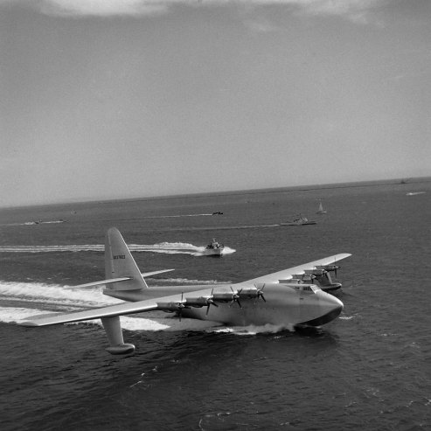 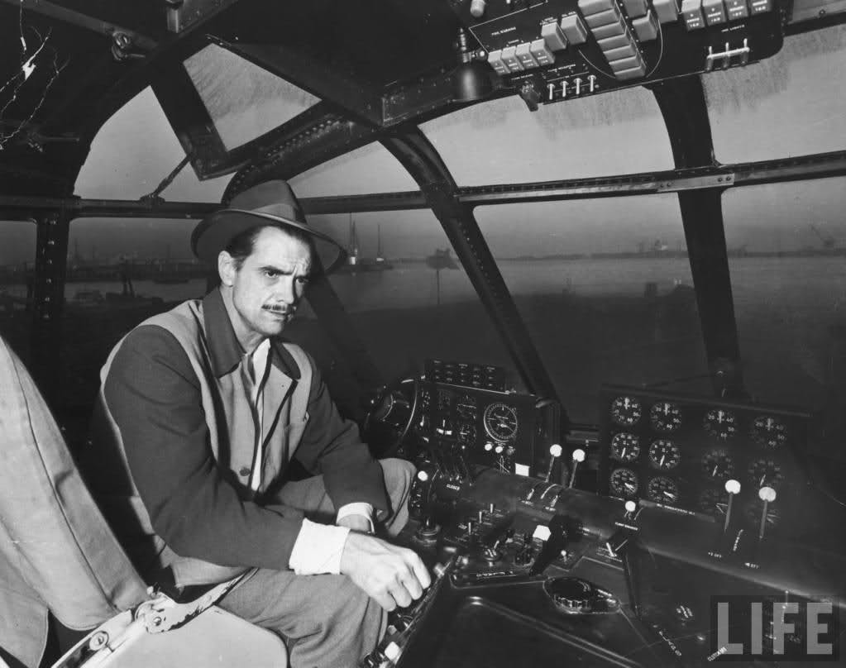
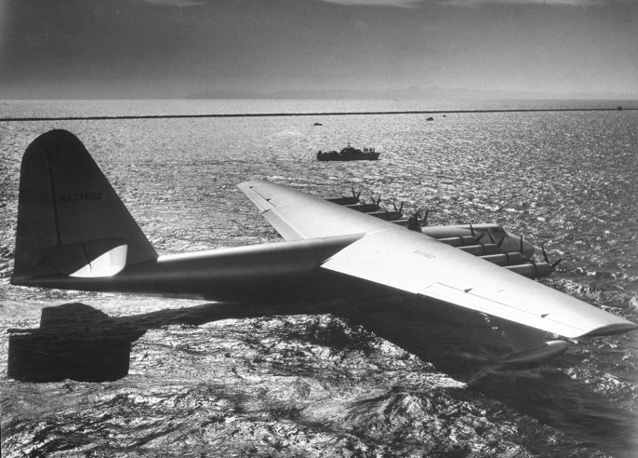
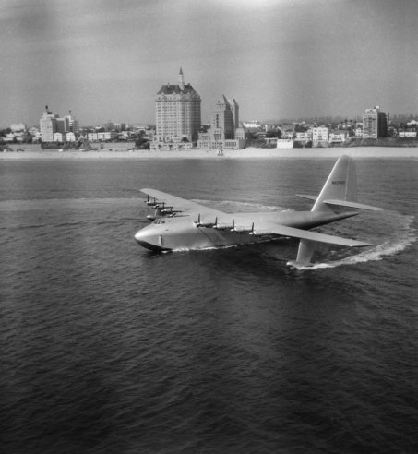
A Google image search using ("spruce goose" | "flying boat") hughes will bring back many more images. Copy and paste this exactly as is, paragraphs and all in order to do a very specific search on the terms I have found to be most useful. Another good search is ("spruce goose" | "flying boat" | h4 | hercules) hughes.

This image is nice because it shows the shadow of the blimp/dirigible where the photographer is located, making the photograph.
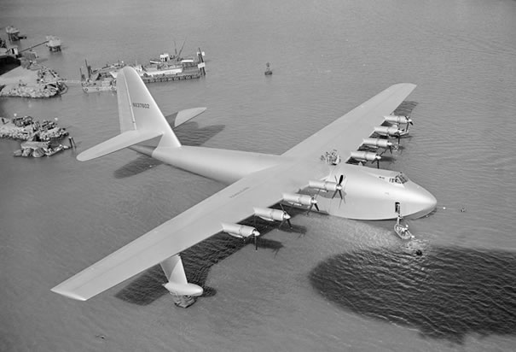
I found this image on the History.com website: http://www.history.com/photos/inventions-transportation/photo12
But the photo credit states that it is from the Bettmann/CORBIS archive. They are located at http://www.corbisimages.com/stock-photos/collection/bettmann

I went to the archive and located this image:
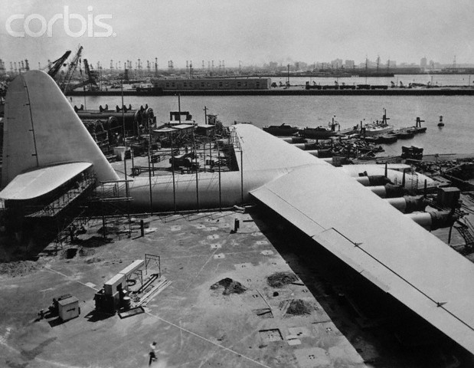

The Spruce Goose Under Construction
Original caption: This is the wing of the Hughes Hercules, world's largest all-wood seaplane, now nearing completion at Culver City, California. It will have a wing-spread of 320 feet (20 feet longer than a football field), and is 13 feet thick at the hull. A B-29 could be placed beneath each wing and still leave space for the hull with a few feet to spare.
Stock Photo ID: SF27108
Date Photographed: July 16, 1945
Model Released: No Release
Property Released: No Release
Location: Culver City, California, USA
Credit: © Bettmann/CORBIS
License Type: Rights Managed (RM)
Category: Historical
Collection: Bettmann
Max File Size: 10 MB - 2986px × 3848px • 9.00in. × 12.00in @ 300 ppi

The Betteman archive may prove very helpful in your image needs. This search http://www.corbisimages.com/Search#rdr=1&mrc=41,398&s=50&p=1&q=spruce+goose brings up lovely images like these:
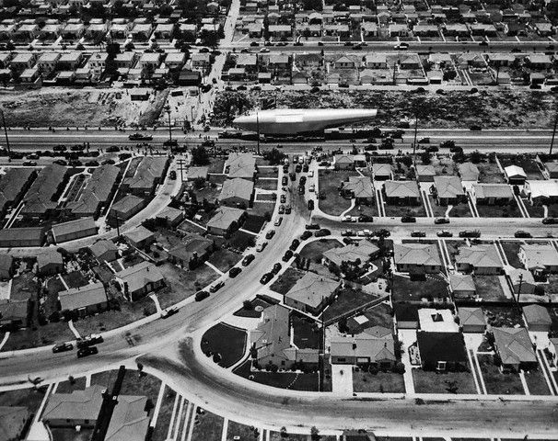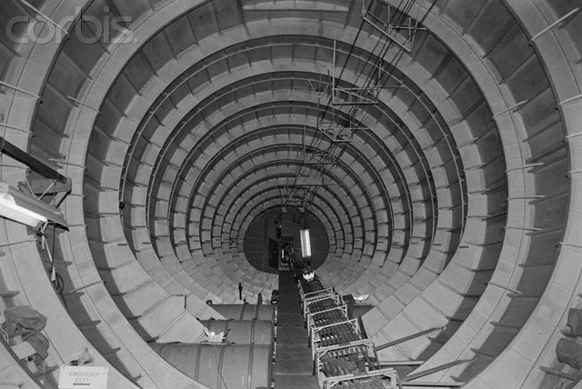
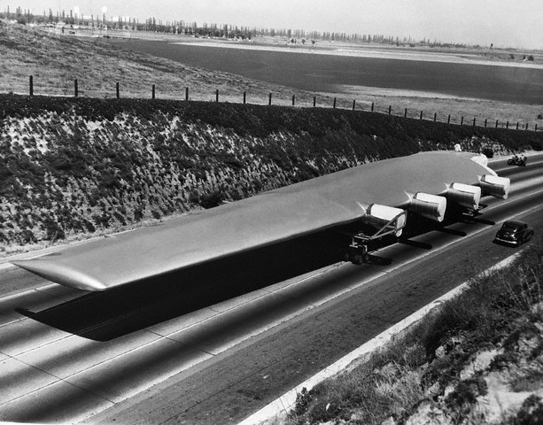
These types of images seem to be most appropriate to go along with your display of the blueprints and other ephemera. They of course have many more, including portraits of Mr. Hughes from several stages of his life.
The Betteman archive also has several images of individuals and these individuals, if identified, may correlate to the individuals in the photographs in your collection allowing you to identify them.

Comics and animation
On a lighter side, there are also comics based on the aircraft and its eccentric creator:
The Simpsons did an episode called $pringfield (Or, How I Learned to Stop Worrying and Love Legalized Gambling) wherein Mr. Burns builds the Spruce Moose. http://www.thesimpsons.com/#/recaps/season-5_episode-10
In 1987 a cartoon was made: Yogi Bear and the Magical Flight of the Spruce Goose http://www.imdb.com/title/tt0088433/

I hope these resources help you and your department in the display and educational needs of the amazing gift of the blueprints and other items from this important time in aviation history. If you or your colleagues have any questions or concerns, please feel to contact me!

Yours,
Bridget Nowlin
Researcher

