Bridget Nowlin
June 1, 2012

Camera Work
The Publication
Camera Work is a publication that was published by Alfred Stieglitz from 1903 to 1917. There were 50 issues published in those 14 years, with 1,000 journals per issue except for the last 2, which had 500. (Philippi, 13) It was published quarterly until it neared the end of the publication, when it became more erratic.
This paper is going to look at this publication as a whole, while focusing on the collection of issues held at the Seattle Public Library’s Seattle Room. I have been sharing this magazine with my history of photography students for several years and always scheduled a visit by my class so they can view and hold Camera Work themselves. I believe strongly in the power of the original object and taking my students from the Photographic Center Northwest never fails. They are studio students who may or may not be excited about taking a history class. They are always moved by the beautiful images within Camera Work and are amazed that they can hold the publication themselves and page through it at their leisure. Many are surprised when they see the color images from the autochromes, while others are taken in by the velvetiness of the photogravures. These images are of such quality that they have even been loaned to the Henry Art Gallery for exhibitions. It really is a marvel that we are allowed to come in to the Seattle Room and visit these publications in person.
I have been excited by this opportunity to spend more time researching into Camera Work and to looking into the particular issues held in the Seattle Room. While I visit with it annually, I am always introducing it to students and this has been my impetus to spend more time with it myself and to do deeper, more personal research. My findings will be shared with the very helpful staff of the Seattle Room and hopefully can help flesh out the knowledge on the publication of which they are fortunate enough to be stewards.
Camera Work was originally begun as a Photo Secessionist publication and later became the mouthpiece of much of the Modernist art movement. Through Camera Work and his gallery, Stieglitz is one of the primary reasons that Modern Art was brought to and accepted by Americans and the art world. Stieglitz brought together writers and artists through Camera Work and via his gallery in New York, many of which had never been seen nor published in the United States including Pablo Picasso and Gertrude Stein. (National Portrait Gallery)
Originally, the photo Secessionists held exhibitions, although notably none in New York, in order to disseminate their ideas about art photography. The main leader of the group, Stieglitz opened what would become an influential gallery at 291 5th Avenue in New York City. It was originally called the Little Galleries of the Photo Secession and changed its name to 291 to reflect the later change in the focus of the gallery away from the photo secessionist movement to the Modern Art movement.
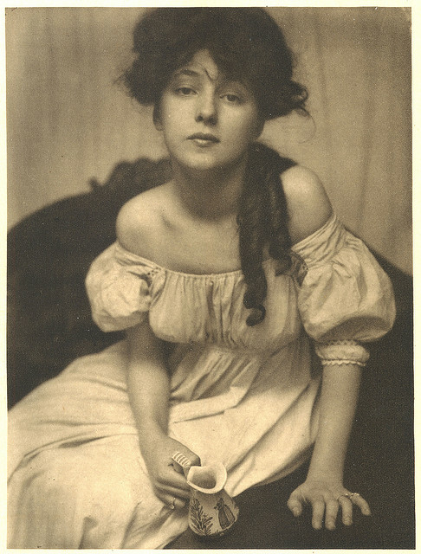
The Photo Secessionists were emulating the Secessionists movements in Europe, most notably the Munich Secessionists. The Photo Secessionists primary goal was to advance photography as a fine art (Oxford, Photo-Secession) and they did this thorough their emulation of subject matter and by the evident hand of the artists in their published and exhibited pieces. The first issue of Camera Work was dominated by the work of Gertrude Käsebier, one of the founders of the Photo Secessionists, whose work uses the then-popular subject matter of women and children depicted via allegory using the Pictorialist approach. I love that the work of a woman was the focus of the first issue of this well-respected journal, one that was admittedly male-dominated in its editors, writers and artists. Men may have been better represented, but a woman was the first. One of Käsebier’s better-known pieces Portrait of Miss N., 1903 (seen right) is in the collection of the Henry Art Gallery and is available for viewing in their Collection Study Center by appointment. This is especially fortunate given that issues 1 and 2 at the Seattle Public Library are not the original publications, but are reprints and this lovely piece on tissue is unfortunately not in the Seattle Room.
image source: www.photogravure.com
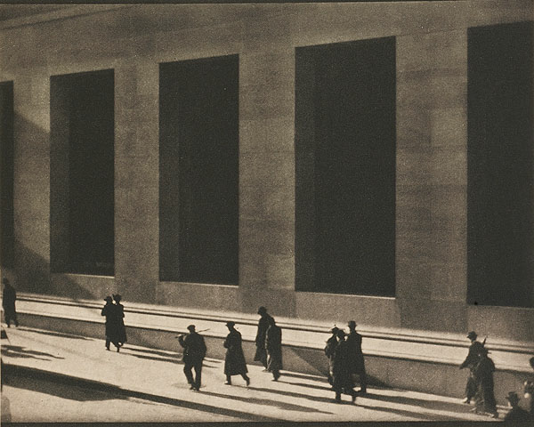
One of the most interesting things about viewing Camera Work in its entire run is the ability to see the great changes in art from 1903 to 1917. Photography goes through a change from Pictorialism to the formalist qualities of Modernism and this focus on Modernist qualities is also seen in works in other media as well. While we have the lovely Miss Nesbit in the first issue, we end with the work of Paul Strand’s Wall Street, 1915 in issue 48 and one can see the changes in vision that have occurred in the 14 years of publication. The soft focus of the Pictorialists has given away to the hard lines and shapes of the Modernists.
Wall Street, 1916 image source: www.photogravure.com

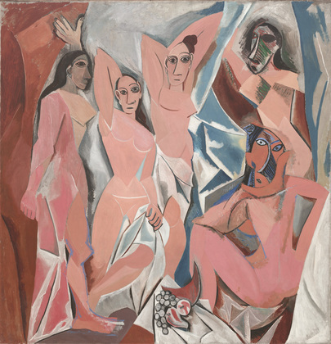
Other examples of this move to Modernism include the inclusion of works by Pablo Picasso and Georges Braque in Camera Work #48 in 1916. It is interesting to note that seminal work from both Picasso (in the form of Demoiselles d’Avignon) and Stieglitz (in the form of The Steerage) were created in 1907. This speaks to the interest in alternative ways of thinking about working in media (painting and photography) in non-traditional ways.
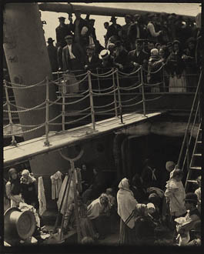

The Steerage, 1907, image source: www.photogravure .com
Demoiselles d’Avignon, 1907, image source: Museum of Modern Art

It also speaks to the relationship that these two men had; Picasso is said have loved The Steerage for it's depiction of multiple planes - the movement in and out of the picture plane and how it work with the abstract, symbolic of cubism. The Steerage was published in Camera Work #36 in October 1911. These comparisons allow the question to no longer be if photography is art, but rather what kind of art is it? It also frees photography from the limitation that photography be necessarily about the subject matter depicted, but rather about formal elements including line, shape and form within the piece itself.
Included with the images published in Camera Work are writings by George Bernard Shaw, Peter Henry Emerson, Robert Demachy, Alfred Stieglitz, Edward Steichen, H. G. Wells, Henri Matisse, Sadakichi Hartmann, Gertrude Stein, Mina Loy, Paul Strand and many, many others. These texts include art criticism, gallery announcements, essays on photography, poems, editorials and other forms of writing. This publication was interested in discussing, showing, and creating works of art and provides a deep understanding of the art world in both the U.S. and Europe during 1903-1917. The style of writing uses a strong, almost melodramatic approach that would be ridiculed if published in this day and age but that speaks to the strong emotions that the authors felt about what they were saying and advocating, especially as the publication moved towards Modernist thought.
As discussed earlier, Gallery 291 and Camera Work also championed non-photographic art: Stieglitz was the first to exhibit controversial (at the time) artists such as Matisse, Degas, Brancusi, Picasso, Marsden Hartley (American painter) and more in the United States, helping with the shift in focus of Paris as the center of the art world to New York (Green). Discussions on art are rampant and discussed vehemently in the covers of Camera Work. As an aside, an anecdote on the irascible Stieglitz and the confusion about Modern art involves the story of a woman coming into 291 and viewing the paintings on the wall. Spying Stieglitz, she approaches him and asks curtly why these artworks do not move her. Stieglitz replies by looking her up and down and saying: tell me this, why do I not get an erection when I look at you! Such was the confusion about the new style of paintings and Stieglitz’ ‘education’ of the public about the work he displayed on his walls.
The people
Alfred Stieglitz was born in Hoboken, New Jersey in 1864 and died in New York, in 1946. He was quite the character and there are many tales out there of his rudeness and straightforward comments to unsuspecting people. The photo historian Robert Leggat stated “Not the easiest of people to get on with, his leadership was little short of dictatorial and he was an insufferable egocentric windbag, but he made a distinct and influential contribution to the development of new styles of photography.” He wore a black cape wherever he went, which added to his mystique. He is well known for his portraits of his second wife the painter Georgia O’Keefe with whom he had a tumultuous and rewarding relationship, often across the country (he lived in New York, she in New Mexico). Oxford Art Online lists him as an “American photographer, editor, publisher, patron and dealer. Internationally acclaimed as a pioneer of modern photography, he produced a rich and significant body of work between 1883 and 1937. He championed photography as a graphic medium equal in stature to high art and fostered the growth of the cultural vanguard in New York in the early 20th century.”

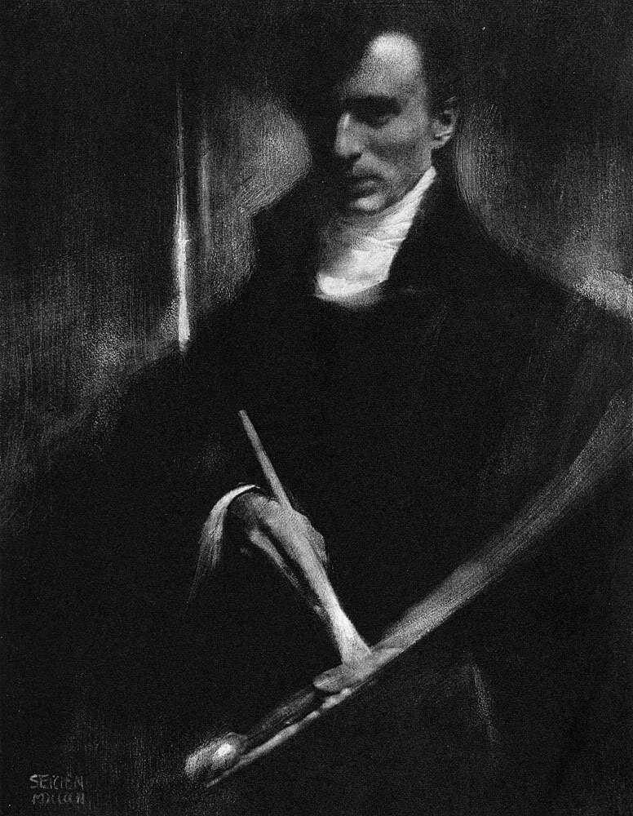
Stieglitz’s right-hand man was Edward Steichen (born Luxembourg, 27 March 1879; d Connecticut, 25 March 1973) He was one of the founders of the Photo-secession group and, in 1903, designed the cover of Camera Work. In 1906 a special edition of his work, The Steichen Book (New York, 1906), was published as a supplement to Camera Work. (Oxford) Steichen came to Stieglitz as a young man and they worked together for many years, only ending their friendship after Steichen refused to give up making art for money, something Stieglitz found extremely distasteful. Steichen’s Self-Portrait, 1903 published in Camera Work, speaks to the idea of photography searching to be accepted as art: Steichen depicts himself as an artist holding the traditional painter’s palette even though he is using a heavily manipulated photogravure that shows extensive evidence of the involvement of the hand of the artist who created this piece.
image source: www.photogravure.com
The covers
The journals at the Seattle Public Library no longer have their covers and this makes it difficult to know when one is moving from one issue to another. This is further complicated by the inconsistent removal of title pages. It is disappointing that the decision was made to remove the covers and I can only surmise that this decision was made in order to save space in the binding. In addition, it appears that the ads were removed, probably as a space-saver as well.
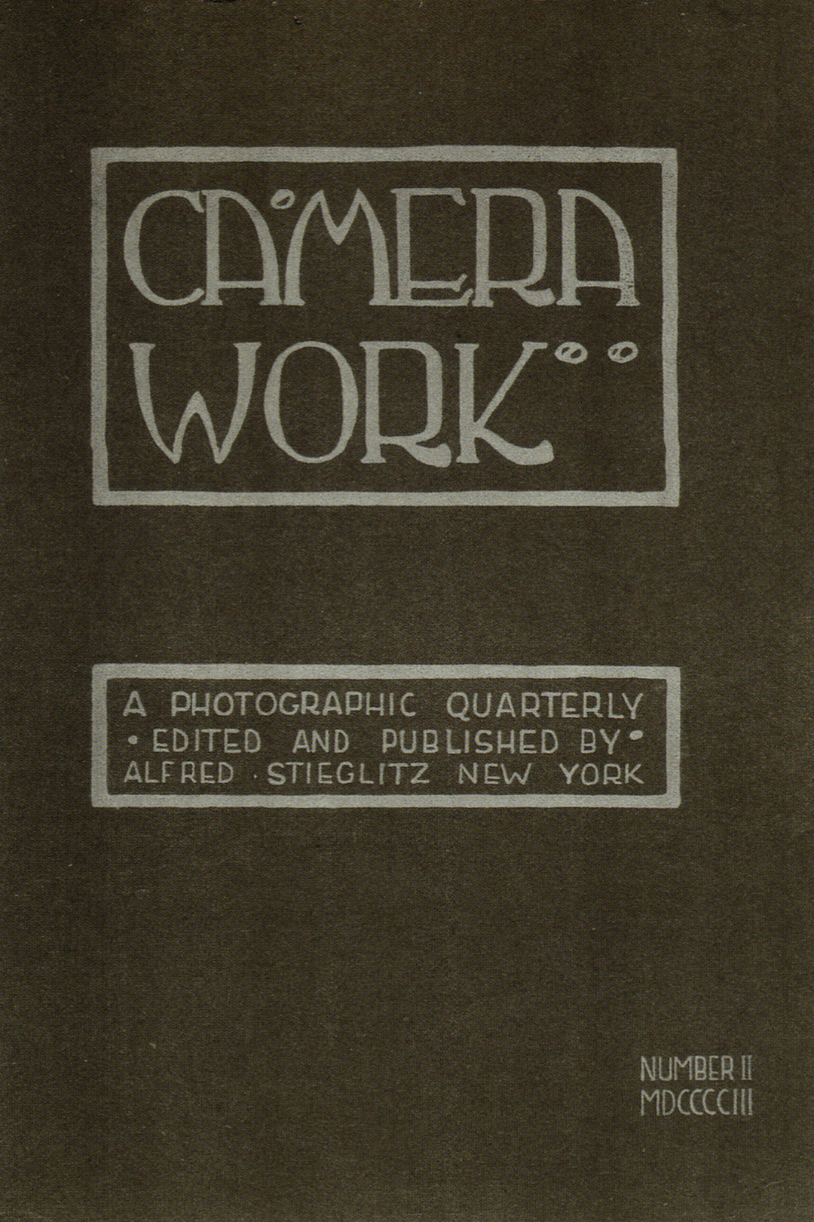
When interviewed at the G. Gibson Gallery in Seattle, Michelle Dunn Marsh, former co-publisher of Aperture magazine, stated that the covers of Camera Work are all the same and made from a very thick paper. Through her work at Aperture, she has been privy to entire collections of Camera Work and even owns one issue. I was pleased to be able to ask her this question, as I have been unable to locate this information definitively elsewhere.
Her answer that the covers are of a thick paper strengthens my idea that it was for practical purposes that the covers were removed, as they would have added bulk to the bindings. As the bindings are nothing special, I imagine that the people making the decisions at the time were concerned more about practical issues rather than historic or aesthetic. For that matter, if they had been concerned with either of these interests, the journals would not have been bound in the first place.
The paper
I asked Sandra Kroupa to look at the journals when they were in the classroom and asked her for more information on the paper that Stieglitz used. Upon inspection, she gave me the surprising news that the paper was likely machine made but made to look as though it was handmade. I was surprised to hear this as Stieglitz took such care with the content and with the reproductions of art, that I thought the same care would have gone into the paper used. While the paper’s color works well with the tones of the artworks, the paper itself is dry and brittle. Closer viewing reveals many cracks in the paper, not tears. Turning the pages needs to be done carefully so as to not add more cracks and the bindings need to be held slightly closed to avoid damaging the pages. Sondra recommends that the bindings be removed as they are doing more harm than good. The bindings (which are discussed in greater detail in the next section) are actually pulling and tearing at the paper. She recommends that the journals be unbinded and placed in acid-free boxes with interleaving tissue. Ironically, Phillipi in Camera Work : the Complete Illustrations 1903-1917 stated that the Japanese tissue-printed images were then mounted onto high quality (emphasis mine) deckled-edged art paper. (Philippi, 14)
Returning to the issue of the paper not being handmade, Sondra stated that she felt the deckle was added later as was the watermark in order to give the appearance of handmade paper. The appearance of handmade paper along with the Art Nouveau design of the cover gave the journal an older, respected feel, something of import to the photo secessionists.
The tissue used in this publication tells us much about Stieglitz and his standards for this creation of the Photo Secessionists. The tissue used and the excellence of the prints and texts on them are of the highest quality. The hand-pulled photogravures are printed on Japanese Tissue (Philippi, 14), which lends an ethereal quality to the works. The paper absorbs and holds the printer’s ink and allows the beauty of the images to remain true 100 years after they were printed. This tissue allows maximum tonal quality and texture. (Philippi, 14)
“The gravures usually were printed on delicate Japanese tissue, mounted on textured papers, and individually tipped into the magazines. In each issue, the illustrations were segregated from the magazine's text, creating discrete portfolios of images for quiet contemplation.” (Art of the Photogravure)
The heavy paper used by Stieglitz further adds to the depth and seriousness of this journal. The paper is a pleasure to touch and holds the ink of the text so strongly that it easy to read even over 100 years after printing (even if it is of poor quality). The photogravures and other images on tissue are mounted by their 4 corners to this same paper. Some of the images have come loose from the heavy paper in the Seattle Public Library issues and one must be careful with these valuable images when viewing Camera Work at the library. Other images ended up being bound right into the multi-issue bindings, especially the bindings that were trimmed.
Four companies did the printing:
- Photochrome Engraving Co. in New York (Katzman)
  - Where Stieglitz used to work and learned about photogravures
- Manhattan Gravure Co.
  - Offshoot of Photochrome Engraving Co. and run by Stieglitz’s brother in law
- T&R Annan & Sons in Glasgow
- Frederick Goetz at Bruckmann Verlag in Munich (Philippi, 15)
Stieglitz had strong standards for his prints, so much so that he would use the photogravures in exhibitions when the original prints were not available. (Green) These prints were usually from the original negatives (Philippi, 15) and this added to the strength of the image since there was only one generation from negative to print rather than 2 generations (negative to print to photogravure). Stieglitz also included mezzotint gravure, duogravure, hand-tinted photogravure, 3 and 4 halftone and collotype (Philippi, 15) prints in Camera Work. He wanted to use the newest methods for reproducing the works of art and each of the 1,000 prints made for the magazine is now worth a great deal.
The bindings at Seattle Public Library
There are 4 different bindings of the issues at Seattle Public Library, indicating that they may have been binded at different times, or by different people (as I will discuss in the case of Dr. Alexander Hamilton Peacock) (Kroupa). This is an intriguing aspect of these particular issues, and one that, while disappointing in some ways, probably also enabled them to be saved and available to the public via the library. Had they not been bound, they probably would have been stolen at some point in time as each issue is worth tens of thousands of dollars (Sotheby’s).
The issues in the Seattle Room are bound as follows:
- 1-4: (not originals)
- 3-7: green, untrimmed, Kraft end paper
- 8-11: green, untrimmed, Kraft end paper
- 12-15: green, untrimmed, Kraft end paper
- 16-19: green, untrimmed, Kraft end paper
- 20-21: green/brown, untrimmed, Kraft end paper
- 22-25: brown, trimmed, SPL endpaper
- 26-29: Peacock binding
- 30-33: brown, trimmed, SPL endpaper
- 34-39: brown, trimmed, SPL endpaper
- 40-43: brown, trimmed, SPL endpaper
- 44-47: Peacock binding
- 48-50: green/brown, untrimmed, Kraft end paper
It is interesting to note that issues 22-25 and 30-43 were all bound in Seattle Public Library endpapers with a logo different from their current logo. According to John Lamont, Genealogy Librarian at Seattle Public Library, this was used on the end papers circa 1957/59 and stopped being used circa 1977. These are the ones that were trimmed, removing some of the character from the pieces. Issues 1-4 are also trimmed, but as these are not originals, this does not have an effect. Issues 3-19 are untrimmed and bound in a green cloth binding while issues 20-21 and 48-50 are untrimmed and bound in a green/brown cloth binding. Sandra thinks it possible that all of the issues may have been bound this way originally and that the ones with the logo endpaper may have been bound this way later due to the original bindings falling apart (as the green/brown bindings are doing). All of these have the lettering “Camera Work” on the side, along with the issue numbers, but the lettering is different and comes in black or gold. Issues 26-29 and 44-47 are bound in a completely different type of binding, one that is completely falling apart. It is a green leather-like material with contrasting corners with the words “Dr. Alexander Hamilton Peacock” embossed on the front. I am working with the Seattle Room staff to access the accession records of these journals in hopes that this will provide more information.
The covers of the bound issues are of a cloth-like material made to be very stiff. The 2 Peacock bindings are of leather that is now falling apart and help together by ribbon tied around each volume.
As examples of the collection, here is a comparison of 2 of the bound issues:
Camera Work 34-39 | Camera Work 48-50
CAMERA WORK//34-39//April 1911-//July 1912//R – al in black lettering on the spine | CAMERA WORK //48-50//1916-17//R – all in gold lettering on the spine
End paper has Seattle Public Library logo printed all over it | Kraft paper endpaper
Pages are all trimmed, presumably done when rebound | Paper not trimmed when rebound
Brown cloth binding | Green/brown cloth binding

At one point several years ago, Jodee Fenton, Manager of Special Collections in the Seattle Room at the Seattle Public Library, thought that the library had had a subscription to Camera Works and that was how they came in to the collection. A more recent conversation shows that she has rethought this and no longer thinks this is the case. The fact that 2 of the bound issues come with Dr. Peacock’s name embossed on them strengthens the idea that this collection does not come as a result of an original subscription. This is a shame, because the original thought of Seattle Public Library having an original subscription to Stieglitz’s publication was an exciting one!
Looking into who Dr. Peacock was, I found that he was, according to the 1914 Who’s Who in the Pacific Coast, a “physician and surgeon; b. Philadelphia, PA June 29, 1880, educated in PA, married Ruth Sutherland Jan. 30, 1906 in Seattle.” He was a member of the Seattle University Physicians, National Geographic Society, American Medical Association, and the American Urological Association. They even have his Queen Anne address (1808 4th Avenue N) (Who’s Who). Given the time period, I can imagine him having an original subscription and of his having his issues bound with his name on them for his personal library. I do wonder what happened to the remainder of his collection.
The business of the journal
Exact costs of publication are unavailable, as Stieglitz kept no detailed accounts. (Philippi, 15) Amounts were kept for his prior publication Camera Notes, and these showed that Stieglitz would use thousands of his own money to keep it going. One can only imagine what a publication such as Camera Work cost.
As an example of the title page found within each issue, I have typed in verbatim the title page text from issue 36:
CAMERA WORK: An Illustrated quarterly magazine devoted to Photography and to the activities of the Photo-secession. Published and edited by Alfred Stieglitz. Associate Editors: Joseph T. Keiley, Dallett Fuguet, J.B. Kerfoot, Paul B. Haviland. Subscription price Eight Dollars (this includes fee for registering and special packing) per year; foreign postage, Fifty Cents extra. All subscriptions begin with Number XXXVI. Back numbers sold only at single-copy price and upward. Price for single copy of this number at present, Eight Dollars. The right to increase the price of subscription without notice is reserved. All copies are mailed at the risk of the subscriber; positively no duplicates. The management binds itself to no stated size or fixed number of illustrations, though subscribers may feel assured of receiving the full equivalent of their subscription. Address all communications and remittances to Alfred Stieglitz, 1111 Madison Avenue, New York, U.S.A. The Japan tissue proofs in this number by Manhattan Photogravure Company, New York; all the other Plates by F. Bruckmann, A.G., Munich, Germany. Arranged and printed at the printinghouse of Rogers & Company, New York. Entered as second-class matter December 23, 1902, at the post-office at New York, N.Y., under the act of Congress of March 3, 1879. This issue, No. 34-35, is dated April-July, 1911.
C.W. (logo)
It is interesting to note that the $8.00 subscription would be approximately the equivalent of $185.00 in 2012 dollars according to several online inflation calculators. This is not an insignificant amount of money, especially given that many subscribers of the first issue subscribed sight unseen! However, it should be noted that the first issues were $4.00 per issue and the price increased as the publication continued. A complete set in their original bindings sold in October 2011 for $398,500.00 USD at Sotheby’s; an amazing price for a complete, intact set. (Sotheby’s)
This has been and will continue to be a fascinating exploration into aspects of this seminal publication by one of the most important names in the field of photography. There were surprises, especially concerning the quality of the paper. I look forward to continuing to work with the issues held at the Seattle Public Library and will share with them my findings as well as the recommendations made by Sandra Kroupa. I am always amazed and thankful that the City of Seattle has this publication available for use by its citizens but am also thankful that it is in the protective hands of the Seattle Room and its staff.
Works Cited
“Early 20th Century ‘Camera Work’ Magazines | Roadshow Archive | PBS.” Web. 26 May 2012.
“(With)holding Camera Work [early Portraits of Alfred Stieglitz with Photography Journal].” History of Photography v. 20 (1996): p. 333–4.
“Alfred Stieglitz: The Aeroplane.” History of Photography v. 28.1 (2004): 41–2.
“Camera Work and the Fluid Discourse of Pictorialism.” History of Photography 23.3 (1999): 294–300.
“Camera Work in Oxford Art Online.” Web. 20 May 2012.
“Camera Work: A Pictorial Guide, with Reproductions of All 559 Illustrations ... - Alfred Stieglitz - Google Books.” Web. 19 May 2012. http://books.google.com/books?hl=en&lr=&id=k45084xm4kMC&oi=fnd&pg=PR7&dq=camera+work+stieglitz&ots=bWI1HHNGXb&sig=NcoJ3PPpot6H4rLHmJB7bOqVeAY#v=onepage&q=camera%20work%20stieglitz&f=false
Carillo, Jeffrey. “Camera Work [Part of a Special Issue: Art Through the Pages: Library Collections at the Art Institute of Chicago].” Museum Studies 34.2 (2008): 46–7.
Green, Jonathan, ed. Camera Work: a Critical Anthology. New York: Aperture, 1973.
Katzman, Mark “Photogravure Gallery.” Web. 28 May 2012. http://www.photogravuregallery.com/about/
Kroupa, Sandra. 24 May and 31 May 2012. Interviews.
LaMont, John. “Library Question - Answer [Question #7729551] - Bnowlin@uw.edu - UW Mail.” Web. 26 May 2012.
Leggat, Robert. “A History of Photography from Its Beginnings till the 1920s.” Web. 29 May 2012. http://www.mpritchard.com/photohistory/index.html
Michelle Dunn Marsh, Former Co-publisher of Aperture Magazine. Interviewed by Bridget Nowlin at G. Gibson Gallery May 19, 2012.
National Gallery of Art - Modern Art and America: : Alfred Stieglitz and His New York Galleries exhibition text. Web. 20 May 2012. http://www.nga.gov/exhibitions/modart_1.shtm
“National Portrait Gallery | Seeing Gertrude Stein: Five Stories.” Web. 29 May 2012. http://www.npg.si.edu/exhibit/stein/steinchronology.html
Perloff, Stephen. “Camera Work: A Centennial Celebration.” American Art Review 15.6 (2003): 162–3.
Philippi, Simone, and Ute Kieseyer, eds. Camera Work :the Complete Illustrations 1903-1917. New York: Taschen, 1997. Web. 24 May 2012.
“Photo-Secession in Oxford Art Online.” Web. 20 May 2012.
Sotheby’s “Photographs | Event Detail / Sotheby’s | Auctions > Photographs - Lot 57 : Alfred Stieglitz, Editor - ‘CAMERA WORK: A PHOTOGRAPHIC QUARTERLY’.” Web. 29 May 2012.
“Stieglitz, Alfred in Oxford Art Online.” Web. 19 May 2012.
“The Art of the Photogravure | Camera Work.” Web. 26 May 2012. http://www.photogravure.com/key_examples/keyworks_camerawork.html

